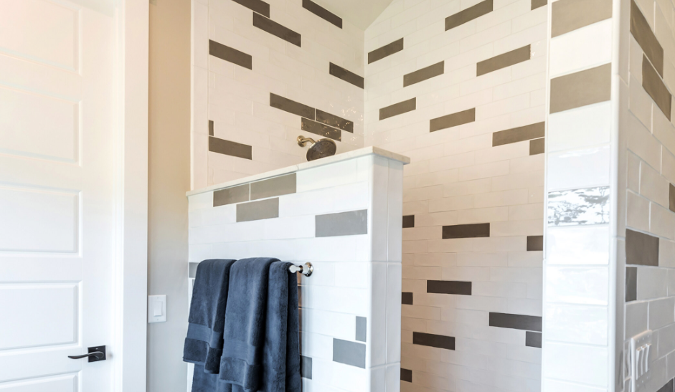

**BATHROOM**

Our bathroom wall tiles selection includes glazed porcelains from the italian manufacturer, Adeline. Italian arabescato and arancetto

marbles now available in Polished finishes.

Available in a wide variety of sizes, shapes, and mosaics.

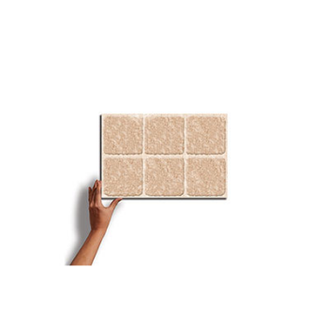

**Lyptus chestnut**

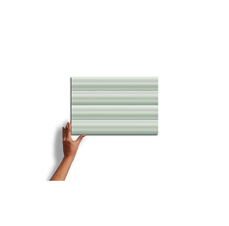

***Michigan decor***

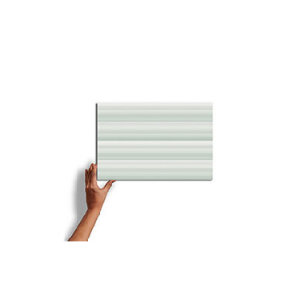

**Douglas fir mocha**

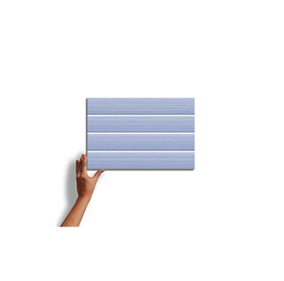

**Avallon earth**



**Michigan bronze**

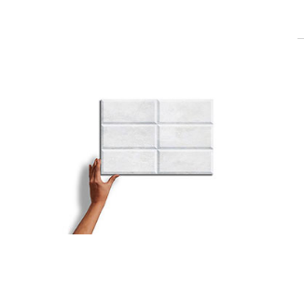

**Sandstone khaki**

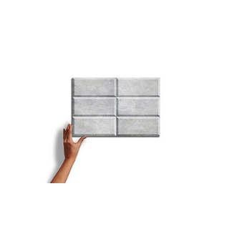

**Sandstone decor**



**Sandstone dune**

**BATHROOM WALL TILES** TECHNICAL INFORMATION

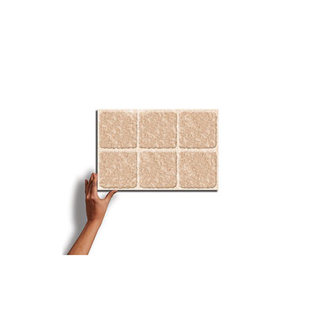

**LYPTUS CHESTNUT**

A beautifully glazed porcelain collection from Italy creates a blend of marbles with a subtle antiqued look. Blending the veining of white Italian marbles (Carrara, Statuario, Gioia, and Venatino) in both White and Black creates a variety of sizes and patterns to create custom designs.

SPECIFICATIONS

**Country of Origin**

Italy

**Wear Rating**

Class 5 Suitable for all Residential and Commercial Application. Class 5 tiles are suitable for all applications including those with heavy traffic and constant use. (i.e., Shopping Malls, Hospitals), Class 3 Residential Applications. Suitable for all residential applications.

**Shade Variation**

V3 - Moderate Variation While the colors present on a single piece of tile will be indicative of the colors to be expected on the other tiles, the amount of colors on each piece will vary significantly.

**Frost Proof**

Yes

**Finish**

Glazed

**Material**

Porcelain

**Bullnose**

Yes

**BATHROOM WALL TILES** TECHNICAL INFORMATION

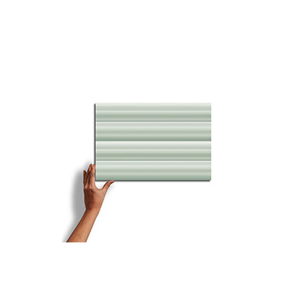

**MICHIGAN DECOR**

A beautifully glazed porcelain collection from Italy creates a blend of marbles with a subtle antiqued look. Blending the veining of white Italian marbles (Carrara, Statuario, Gioia, and Venatino) in both White and Black creates a variety of sizes and patterns to create custom designs.

SPECIFICATIONS

**Country of Origin**

pakistan

**Wear Rating**

Class 5 Suitable for all Residential and Commercial Application. Class 5 tiles are suitable for all applications including those with heavy traffic and constant use. (i.e., Shopping Malls, Hospitals), Class 3 Residential Applications. Suitable for all residential applications.

**Shade Variation**

V3 - Moderate Variation While the colors present on a single piece of tile will be indicative of the colors to be expected on the other tiles, the amount of colors on each piece will vary significantly.

**Frost Proof**

Yes

**Finish**

Glazed

**Material**

Porcelain

**Bullnose**

Yes

**BATHROOM WALL TILES** TECHNICAL INFORMATION

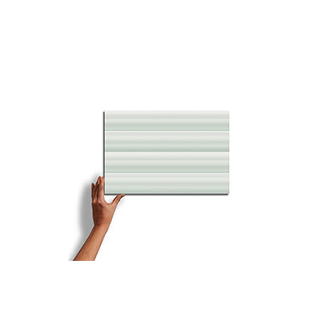

**DOUGLAS FIR MOCHA**

A beautifully glazed porcelain collection from Italy creates a blend of marbles with a subtle antiqued look. Blending the veining of white Italian marbles (Carrara, Statuario, Gioia, and Venatino) in both White and Black creates a variety of sizes and patterns to create custom designs.

SPECIFICATIONS

**Country of Origin**

Italy

**Wear Rating**

Class 5 Suitable for all Residential and Commercial Application. Class 5 tiles are suitable for all applications including those with heavy traffic and constant use. (i.e., Shopping Malls, Hospitals), Class 3 Residential Applications. Suitable for all residential applications.

**Shade Variation**

V3 - Moderate Variation While the colors present on a single piece of tile will be indicative of the colors to be expected on the other tiles, the amount of colors on each piece will vary significantly.

**Frost Proof**

Yes

**Finish**

Glazed

**Material**

Porcelain

**Bullnose**

Yes

**BATHROOM WALL TILES** TECHNICAL INFORMATION

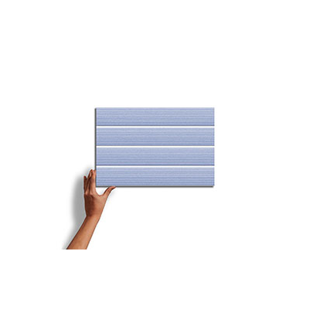

**AVALLON EARTH**

A beautifully glazed porcelain collection from Italy creates a blend of marbles with a subtle antiqued look. Blending the veining of white Italian marbles (Carrara, Statuario, Gioia, and Venatino) in both White and Black creates a variety of sizes and patterns to create custom designs.

SPECIFICATIONS

**Country of Origin**

Germany

**Wear Rating**

Class 5 Suitable for all Residential and Commercial Application. Class 5 tiles are suitable for all applications including those with heavy traffic and constant use. (i.e., Shopping Malls, Hospitals), Class 3 Residential Applications. Suitable for all residential applications.

**Shade Variation**

V3 - Moderate Variation While the colors present on a single piece of tile will be indicative of the colors to be expected on the other tiles, the amount of colors on each piece will vary significantly.

**Frost Proof**

No

**Finish**

Glazed

**Material**

Porcelain

**Bullnose**

Yes

**BATHROOM WALL TILES** TECHNICAL INFORMATION

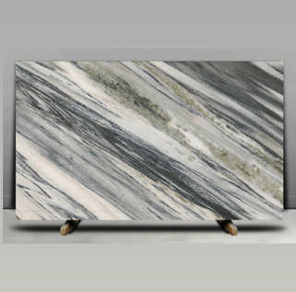

**MICHIGAN BRONZE**

A beautifully glazed porcelain collection from Italy creates a blend of marbles with a subtle antiqued look. Blending the veining of white Italian marbles (Carrara, Statuario, Gioia, and Venatino) in both White and Black creates a variety of sizes and patterns to create custom designs.

SPECIFICATIONS

**Country of Origin**

Italy

**Wear Rating**

Class 5 Suitable for all Residential and Commercial Application. Class 5 tiles are suitable for all applications including those with heavy traffic and constant use. (i.e., Shopping Malls, Hospitals), Class 3 Residential Applications. Suitable for all residential applications.

**Shade Variation**

V3 - Moderate Variation While the colors present on a single piece of tile will be indicative of the colors to be expected on the other tiles, the amount of colors on each piece will vary significantly.

**Frost Proof**

Yes

**Finish**

Glazed

**Material**

Porcelain

**Bullnose**

No

**BATHROOM WALL TILES** TECHNICAL INFORMATION

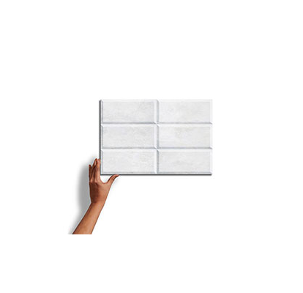

**SANDSTONE KHAKI**

A beautifully glazed porcelain collection from Italy creates a blend of marbles with a subtle antiqued look. Blending the veining of white Italian marbles (Carrara, Statuario, Gioia, and Venatino) in both White and Black creates a variety of sizes and patterns to create custom designs.

SPECIFICATIONS

**Country of Origin**

Grecce

**Wear Rating**

Class 5 Suitable for all Residential and Commercial Application. Class 5 tiles are suitable for all applications including those with heavy traffic and constant use. (i.e., Shopping Malls, Hospitals), Class 3 Residential Applications. Suitable for all residential applications.

**Shade Variation**

V3 - Moderate Variation While the colors present on a single piece of tile will be indicative of the colors to be expected on the other tiles, the amount of colors on each piece will vary significantly.

**Frost Proof**

Yes

**Finish**

Glazed

**Material**

Porcelain

**Bullnose**

Yes

**BATHROOM WALL TILES** TECHNICAL INFORMATION

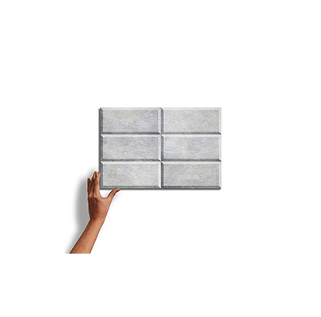

**SANDSTONE DECOR**

A beautifully glazed porcelain collection from Italy creates a blend of marbles with a subtle antiqued look. Blending the veining of white Italian marbles (Carrara, Statuario, Gioia, and Venatino) in both White and Black creates a variety of sizes and patterns to create custom designs.

SPECIFICATIONS

**Country of Origin**

India

**Wear Rating**

Class 5 Suitable for all Residential and Commercial Application. Class 5 tiles are suitable for all applications including those with heavy traffic and constant use. (i.e., Shopping Malls, Hospitals), Class 3 Residential Applications. Suitable for all residential applications.

**Shade Variation**

V3 - Moderate Variation While the colors present on a single piece of tile will be indicative of the colors to be expected on the other tiles, the amount of colors on each piece will vary significantly.

**Frost Proof**

Yes

**Finish**

Glazed

**Material**

Porcelain

**Bullnose**

Yes

**BATHROOM WALL TILES** TECHNICAL INFORMATION



**SANDSTONE DUNE**

A beautifully glazed porcelain collection from Italy creates a blend of marbles with a subtle antiqued look. Blending the veining of white Italian marbles (Carrara, Statuario, Gioia, and Venatino) in both White and Black creates a variety of sizes and patterns to create custom designs.

SPECIFICATIONS

**Country of Origin**

Italy

**Wear Rating**

Class 5 Suitable for all Residential and Commercial Application. Class 5 tiles are suitable for all applications including those with heavy traffic and constant use. (i.e., Shopping Malls, Hospitals), Class 3 Residential Applications. Suitable for all residential applications.

**Shade Variation**

V3 - Moderate Variation While the colors present on a single piece of tile will be indicative of the colors to be expected on the other tiles, the amount of colors on each piece will vary significantly.

**Frost Proof**

Yes

**Finish**

Glazed

**Material**

Porcelain

**Bullnose**

Yes

NOTES

Always inspect materials prior to installation.

Always mix 2-3 cartons at a time while installing to insure the best blend.

Per ANSI standard A108.02,4.3.82, tiles longer than 18” should not be staggered more than 1/3

the length of the tile.

All product images are representation only. Variation in color and shading is to be expected.

Final selection should be made from actual tile samples.